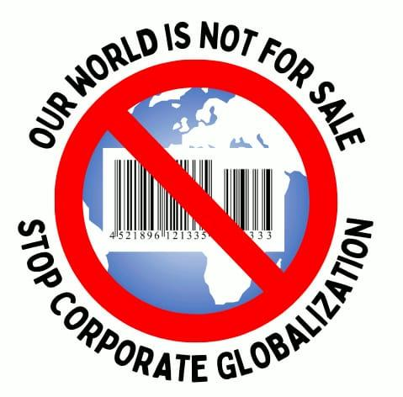

Our World Is Not For Sale
OWINFS

Press release at 14th Ministerial of the WTO, 3 PM, March 28

Five speakers from the OWINFS network presented views on different key subjects being negotiated at the Ministerial, focusing on the current stage of the negotiations, likely outcomes, and their impact on developing countries.

Melanie Foley, from Public Citizen, US, opened as the moderator. She observed how at the Ministerial it seems that in response to Trump's "might makes right" approach to trade, and under the banner of "reform", developed countries are pushing an agenda that will make the WTO even more undemocratic by weakening special and differential treatment, advancing mandate-less plurilaterals, and discarding consensus-based multilateral decision-making. Combine that with a narrow, facilitator-dominated process and civil society sidelined from influencing negotiations, and you get a recipe for disaster.

Here in Yaounde, we have seen a continuation of what has been the real problem. Our multilateral trading system has not delivered on the promise of a rising tide lifting all boats. Instead, all but the wealthiest are drowning. The answer is not the so-called reform on offer that reinforces the power politics that have always been at the core of WTO. It is an entirely different set of rules that supports development, disciplines corporate power, and centers human wellbeing and environmental sustainability.

Next. Parminder Jeet Singh, with Just Net Coalition, spoke about the E-commerce Moratorium. He expressed surprise and disbelief how member countries can be thinking of again signing on a Moratorium document whose coverage, everyone admits, is clear to none, and certainly not shared among the WTO members. How can international agreements be made with lack of clarity, and indeed deliberate obfuscation, and the center of it. Members should certainly discontinue the E-Commerce Moratorium, and bury it in Yaounde forever.
The real purpose of the Moratorium, Mr Singh explained, is to preempt any country in the future from ever border-taxing AI, which will soon be the biggest value flow across borders. It will lead to major job losses everywhere, and severe wage depression. Even Big Tech leaders in the US say that in such conditions, governments will have to tax AI companies for universal basic income and other welfare programs. But whom and how will developing countries tax, with all or by far the most, global AI coming just from two countries, the US and China.

It was followed by Kinda Mohamadieh of the Third World Network. She asserted that the incorporation of the Investment Facilitation Agreement (IFA) – which is NOT about development – and is being pushed at the MC 14, will be the precedent that determines the governance of future plurilaterals at the WTO, and could open the flood gates to plurilaterals that usher the demise of the multilateral trading system. All WTO Members, particularly developing countries and those who joined the IFA, should ensure that guardrails are set in place before the IF incorporation to preserve primacy for multilateralism and ensure that plurilateral agreements are initiated, negotiated and adopted in line with the WTO rules and its consensus decision-making.

Next, Terence Repelente from the The World Forum of Fisher People (WFFP) declared that: We, fisherfolk under the World Forum of Fisher Peoples (WFFP), reject the WTO Agreement on Fisheries Subsidies as a clear failure to stop overfishing and an attack on our livelihoods. It risks stripping the already minimal support for traditional fisher peoples while enabling those who can survive without subsidies—large industrial fleets—to further dominate our waters. The WTO has no business governing fisheries and these decisions must be taken out of trade negotiations and moved to spaces like the UN’s Food And Agriculture Organization’s (FAO’s) Committee on Fisheries.

At this point we have lost all hope that our voices will be heard. It is clear that we are not included from these negotiations that will potentially decide the future of our communities. Instead, these matters are discussed behind closed doors involving people who are not directly impacted and who do not know our struggle. That is why we think that fisheries should not be treated as a commodity and that such discussions should be kept out of the WTO and instead be moved to UN FAO’s COFI where we have at least a space to express our side.

The last speaker was Abhijit Das, an independent trade researcher based in India. He said that the MC14 is set to witness, and may already be witnessing, tough negotiations on agriculture – a subject in which some of the agriculture export powerhouses are seeking a mandate to relaunch negotiations with new approaches. As we are speaking, in the Ministerial Session on Agriculture, during 3:30 pm to 6 pm, Ministers are deliberating on the following two questions: “What are the causes for the current impasse in the agriculture negotiations and how can we address them, including through potential new approaches and possible flexibilities that delegations can offer?"

Adopting new approaches to negotiations implies going back to the drawing board and ignoring the existing ministerial mandates. This would have far reaching and damaging implications for a vast number of developing countries. They would have to start their battle afresh for the three mandated issues – permanent solution to public stock-holding for food security purposes; reduction in cotton subsidies; and protecting farm livelihoods from import surges and cheap and subsidised imports through a Special Safeguard Mechanism (SSM). Developing countries may also have to fight an uphill battle to retain the special and differential treatment provisions in their favour. New approaches to agriculture subsidy reduction could erode the flexibility of developing countries to provide subsidised power, fertiliser and irrigation to their low income, or resource poor farmers, while allowing the developed countries to continue with their high farm subsidies. Finally, global agri-businesses in the US, the EU and a few other countries would seek to pry open agriculture markets in developing countries by getting them to lower their bound tariffs. This would open the flood gates for cheap imports, thereby jeopardising the livelihoods of hundreds of millions of resource-poor subsistence farmers in many developing countries. The outcome on agriculture at
MC14 could provide a pathway for future negotiated outcomes, which could deal a severe blow to food security, and consequently economic security of the developing countries. It is important that developing countries have special and differential treatment for providing support to their farmers.

Contact person for any further information or clarification
Parminder Jeet Singh, parminder.js.work@gmail.com

